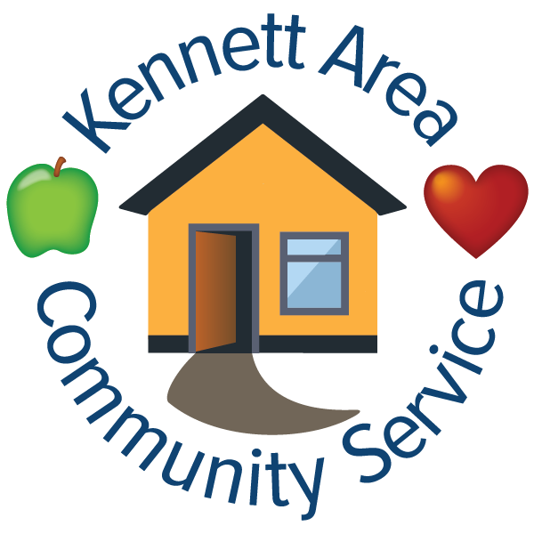
Kennett Area Community Service
Job Posting: Emergency Assistance Advocate

Make a real impact and join our team! Help end extreme poverty. Come work as an Emergency Assistance Advocate with us!

Kennett Area Community Service (KACS) is the premier agency in southern Chester County providing essential, life-sustaining services. KACS, home of the Kennett Food Cupboard has been serving the community of southern Chester County with food, shelter, emergency assistance, crisis services, and facilitating Getting Ahead workshops based on the Bridges Out of Poverty model for almost 70 years.

The (Social Worker) Emergency Assistance Advocate (EAA) is a full-time position that is responsible for assessing the needs of participants in high-crisis, creating household stabilization plans with participants, and providing case management to participants experiencing a housing crisis. The EAA provides support and expertise through comprehensive assessment, planning, implementation, and overall evaluation of individual participant needs. Relationship building is a central component of this position, requiring the use of the Bridges Out of Poverty Framework to build resources.

Salary Range:
$50,000-$55,000 and a signing bonus!

REQUIRED:

- A BSW or equivalent degree in Human Services or related field with three years in Case Management – and bilingual, fluent English/Spanish.
- Strong computer skills and data management is necessary for this role.
- Experience working with families and individuals in housing crisis is strongly preferred.
- At least two year’s of experience with demonstrated effectiveness in serving homeless or at-risk families, including home visits.
- Proficient with Microsoft Office software.
- Ability to communicate with diverse populations.
- Familiarity with social, health, and benefit resources in the service area.
- Reliable transportation to perform home visits and mobile outreach with car insured for business purposes.
- The ability to be nonjudgmental, to be concerned and caring towards the families on his or her caseload, and the ability to understand and/or relate to families.
- Ability to effectively communicate complex requirements to clients and to obtain personal, detailed information affecting the participant's eligibility for programs and services.
- Ability to establish and maintain effective working relationships with participants and coworkers.
- General knowledge of housing program regulations and administrative procedures.
- General knowledge of fair housing laws and regulations, tenants’ rights and responsibilities.

Bachelors Degree in Social Work is REQUIRED as is being bilingual, fluent English/Spanish. Prior experience working with families and individuals in housing crises is strongly preferred. Excellent communication and interpersonal skills are required as well as the ability to work with a diverse population.

KACS offers the following benefits for full-time employees:
- Health Insurance Plan
- Dental Insurance Plan
- Employee Assistance Plan
- $20,000 Life Insurance Plan
- SIMPLE IRA Retirement Plan (KACS matches up to 3%)
- Partial Cell Phone Reimbursement
- Generous paid time off, along with 12 paid holidays

If interested in applying for this opportunity please email a cover letter, resume, 3 professional references, and a diversity statement to Leah Reynolds, Executive Director, Leah@KACSImpact.org. No calls, please.

KACS Mission Statement:
Strengthening the community in Southern Chester County through food, housing, crisis services and education.

Vision:
A community without poverty where everyone can live well.

Values:
· Self-Determination: People have a right to make choices about how to live their lives and work toward their goals.
· Community Led: Everyone benefits when those experiencing resource gaps lead us toward solutions.
· Integrity: We are authentic, ethical, and transparent.
· Effectiveness: We value and maximize the resources given.
· Social Justice: We advocate within political, economic, and social systems to promote distribution of resources and opportunities.
· Collective Impact: We are committed to collaborate with every sector of the community in building solutions to confront the causes and effects of poverty.
· Community Benefit: Every individual, institution and sector has varying resource gaps and strengths. We seek to make connections to benefit all.

